

CS 319 - Object-Oriented Software Engineering  
Analysis Report

Dragon Valley

Fall 2015 – Section 1 – Group 11

Ömer Akgül - 21301854

Güray Baydur - 21300715

Burak Bör - 21200595

Orkhan Namazov – 21002716

**Table of Contents**

1. INTRODUCTION (PROBLEM STATEMENT)………………………...3
2. REQUIREMENT ANALYSIS…………………………………………...5
   1. Overview……………………………………………………….……..5
   2. Functional Requirements…………………………………………......6
   3. Non-Functional Requirements……………………………………….8
   4. Constraints……………………………………………………………9
   5. Scenarios………………………………………………………….…..9
   6. Use Case Model……………………………………………………..15
   7. User Interface……………………………………………………….22
3. ANALYSIS……………………………………………………………...31
   1. Object Model………………………………………………………..31
      1. Domain Lexicon……………………………………………...31
      2. Class Diagram………………………………………………...35
   2. Dynamic Models…………………………………………………….38
      1. State Charts……………………………………………………38
      2. Sequence Diagrams……………………………………...……40
4. CONCLUSION……………………………………………………...…..45
5. ***Introduction (Problem Statement)***

“Dragon Valley” is a basic game that originated from the old popular mobile phone game “Snake”. “Snake” is a game that player tries to control the snake -whose shape is like a straight line- with arrow keys and tries to eat as many as fruits without crossing over on its body (snake’s body grows when it eats a fruit). There are lots of games that used “Snake’s” template. Likewise, in our project, we used this template and tried to add new features to the original game to create a more fun and different game from its ancestor to break its monotonous gameplay which is the problem of the original game.

The purpose of “Dragon Valley” is the same as its ancestor: Try to eat as many as animals with our dragon without crossing over its body but there are different types of challenges and levels differ from the original game!

The game is a desktop application, it’s written with Java and can be controlled by arrow keys and space button on the keyboard.

This report is an analysis of the system we developed which can be seen as a requirements specification report. It includes description of the case, analysis of requirements like functional and non-functional requirements, constraints, scenarios of the system, use case diagrams, user interface visuals, class diagrams of object models, state charts and sequence diagrams of dynamic models.

Our project’s main goal is to provide a more intriguing and challenging game time distinctively than classical “Snake” game. The original game is promising a fun game time that will need player’s attention and reflex capabilities but it is very monotonous. Player always tries to survive and gain points in the same area and it can be boring after some play time. Our goal is to take this “surviving and gaining points” template and adding new features that would make the game more fun. Briefly, we tried to create a more versatile game including new challanges and saving the template from becoming an ordinary game.

There are different animals whose can give our dragon different points. There are some blocks and enemies and our dragon is capable of breathing fire from its head and with this fire, it can destroy these different types of foes to gain more points. There are different stages with different difficulty levels and our dragon must reach a point threshold to pass to next stage.

1. ***Requirement Analysis***
   1. ***Overview***

“Dragon Valley” is a survival arcade game which is easy to play and provide fun game time while trying to reach next stages. Basically, the game have a board and all of the game continues on this board. Player controls our dragon with arrow keys on the keyboard whose shape is like a straight line which can turn left, right, top and bottom. Initially, it starts small and becoming longer with gaining more points. The game will be over if a player’s dragon crosses over with its own body or on an enemy or a block.

There are different types of animals in the game which our dragon have to go through and eat them. By doing this, player gains points according to type of the animal. They all have different point values. They randomly appear on the board and some of them appears rarely in compare to other animals.

Player have to reach a threshold to pass to the next level. In every stage, game becoming difficult and hard to survive on the board. There are different foes occuring in the next levels. There are blocks and enemies that player have to take them out using dragon’s fire by pressing space button on the keyboard.

Before starting the game, program asks user’s name and keeping user’s name and score after the game in the database. So, many players can play the game and compare their score with the other ones who played before. There is a leaderboard on the screen that player can see his/her place on the leaderboard. After game ends, there is a full leaderboard appears on the screen and shows player’s place in the leaderboard. Also there are other notifications appear on the screen when game is over or game is paused.

There will be a main menu when the program starts and there are some options on the menu like starting a new game, seeing instructions of the game (help), muting the game (there will be a music playing on the background), chancing the difficulty of the game, checking the credits and the leaderboard.

* 1. ***Functional Requirements***

- The user should be able to select any feature of the menu.

1. The user should be able to enter a new game.

2. The user should be able to go into options.

3. The user should be able to learn the rules of the game from help.

4. The user should be able to see leaderboard.

5. The user should be able to quit the game.

1) The user should be able to enter a new game.

a. The user should be able to restart game any time during a game stage.

b. The user should be able to pass the current stage (choose the difficulty).

c. The user should be able to end game.

d. The user should be able to see the player that was recently beaten and is closest to beat.

e. The user should be able to see her current score.

f. The user should be able to view the points from recently eaten animal.

g. The user should be able to fire with its dragon.

h. The user should be able to move his dragon to right, left, up and down.

i. The user should complete the stage until the given time ends.

2) The user should be able to go into options.

a. The user should be able to adjust sound.

b. The user should be able to select the difficulty level.

3) The user should be able to learn the rules of the game.

a. The user should be able to see the instructions.

4) The user should be able to see the leaderboard.

a. The user should be able to observe the top players with their highscores.

5) The user should be able to quit the game.

a. The user should be able to close the menu.

* 1. ***Non-Functional Requirements***

**A. Usability Requirements**

1) The player should be able to understand the flow of the game from help section.

2) When the player understands that she is going to lose, she can quickly restart the game from the menu which is located at the upper part of the screen.

3) The player should be able to quit the game whenever she wants.

4) Game screen must be designed properly for upper menu, blocks, enemies, dragon and etc.

5) The stages must be changed from the upper menu during gameplay.

6) Difficulty of the stages must be adjusted sensitively since the difficulties may be so hard or so easy to pass.

**B. Implementation Requirements**

1) Adding blocks, animals, in other words, creating a stage must not be hard to apply on the system. The code must be clear enough to be understood by any developer.

**C. Performance Requirements**

1) The run time of the game should be fast enough to play without delays.

2) Creation of stage should not take more than 2 seconds.

* 1. ***Constraints***

The language of the implementation must be Java and the IntelliJ IDE and Eclipse must be used for developing the game. Most of the contemporary games are written in Java or C++ so Java is a good option to select. Also IntelliJ IDE and Eclipse is easy to use with Github, each member of the group can contribute via Github and see the results quickly in IntelliJ environment.

The game should be analyzed, designed and implemented according to instructions that is given in CS319 Object Oriented Software Engineering Course. The examples from the lecture slides are the primary source for the creation of each diagram. The criteria of the course is the fundamental obligatory for the project.

* 1. ***Scenarios***

**Scenario Name:** Play the current stage successfully

Player opens the Main Menu of the Game. The System displays 6 Buttons with the names New Game, Leaderboard, Options, Help, Credits, Exit Menu. Player clicks on the New Game Button. After that the system initializes a board object in which the stage will be illustrated. The board object creates grids in which the dragon will travel and also enemies and blocks are placed by calling drawBoard (BufferImage) method. Then according to default settings in the options menu, a stage object is created by calling createStage(StageNumber) method. In addition to the creation of submenu, animals, blocks ,dragon and board, the Game Controller object will start the game. The time to complete the current stage begins. For each moment Game Controller object updates each object inside the game by calling their update methods. It simply redraws blocks and enemies if they are not destroyed by the fire of the dragon and also redraws animals. If a animal is eaten by the dragon which is controlled by the player, the score object is updated. Player moves the dragon without collision with blocks and enemies. The player earns enough points to open the door that allows player to continue on next stage. The player moves towards the door and the stage is completed.

**Scenario Name:** Play the last stage successfully

Player goes into the last stage of the game. After that the system initializes a board object in which the stage will be illustrated. The board object creates grids in which the dragon will travel and also enemies and blocks are placed by calling drawBoard (BufferImage) method. Then according to default settings in the options menu, a stage object is created by calling createStage(StageNumber) method. In addition to the creation of submenu, animals, blocks ,dragon and board, the Game Controller object will start the game. The time to complete the current stage begins. For each moment Game Controller object updates each object inside the game by calling their update methods. It simply redraws blocks and enemies if they are not destroyed by the fire of the dragon and also redraws animals. If a animal is eaten by the dragon which is controlled by the player, the score object is updated. Player moves the dragon without collision with blocks and enemies. The player earns enough points to open the door that allows player to continue on next stage. The player moves towards the door and the stage is completed. The Leaderboard and Database is updated if the player reaches the highest score. The system turns the player back to the main menu.

**Scenario Name:** Dragon dies by interaction with an enemy

Player opens the Main Menu of the Game. The System displays 6 Buttons with the names New Game, Leaderboard, Options, Help, Credits, Exit Menu. Player clicks on the New Game Button. After that the system initializes a board object in which the stage will be illustrated. The board object creates grids in which the dragon will travel and also enemies and blocks are placed by calling drawBoard (BufferImage) method. Then according to default settings in the options menu, a stage object is created by calling createStage(StageNumber) method. In addition to the creation of submenu, animals, blocks ,dragon and board, the Game Controller object will start the gameThe time to complete the current stage begins. For each moment Game Controller object updates each object inside the game by calling their update methods. It simply redraws blocks and enemies if they are not destroyed by the fire of the dragon and also redraws animals. If a animal is eaten by the dragon which is controlled by the player, the score object is updated. Player moves the dragon without collision with blocks. However, with a little slow reaction, the player runs into an enemy. The Game Controller stops the Game and displays the Game over Screen.

**Scenario Name:** Dragon dies when time ends

Player opens the Main Menu of the Game. The System displays 6 Buttons with the names New Game, Leaderboard, Options, Help, Credits, Exit Menu. Player clicks on the New Game Button. After that the system initializes a board object in which the stage will be illustrated. The board object creates grids in which the dragon will travel and also enemies and blocks are placed by calling drawBoard (BufferImage) method. Then according to default settings in the options menu, a stage object is created by calling createStage(StageNumber) method. In addition to the creation of submenu, animals, blocks ,dragon and board, the Game Controller object will start the game. The time to complete the current stage begins. For each moment Game Controller object updates each object inside the game by calling their update methods. It simply redraws blocks and enemies if they are not destroyed by the fire of the dragon and also redraws animals. If a animal is eaten by the dragon which is controlled by the player, the score object is updated. Player moves the dragon without collision with blocks and enemies. Nevertheless, player forgets to collect enough animals to obtain sufficient points for the current stage and the system notifies him by displaying a dynamic message that the game will be over if he does not eat more animals. Moreover, player does not reach enough points to open the door so the game controller ends the game and the system displays game over screen.

**Scenario Name:** Dragon dies by interaction with a block

Player opens the Main Menu of the Game. The System displays 6 Buttons with the names New Game, Leaderboard, Options, Help, Credits, Exit Menu. Player clicks on the New Game Button. After that the system initializes a board object in which the stage will be illustrated. The board object creates grids in which the dragon will travel and also enemies and blocks are placed by calling drawBoard (BufferImage) method. Then according to default settings in the options menu, a stage object is created by calling createStage(StageNumber) method. In addition to the creation of submenu, animals, blocks ,dragon and board, the Game Controller object will start the game. The time to complete the current stage begins. For each moment Game Controller object updates each object inside the game by calling their update methods. It simply redraws blocks and enemies if they are not destroyed by the fire of the dragon and also redraws animals. If a animal is eaten by the dragon which is controlled by the player, the score object is updated. Player moves the dragon without collision with enemies. Nevertheless, player does not react quick enough to prevent hitting a block. The Game Controller realizes a collision occurred at that moment and ends the game. The system displays the game over screen which is showing the reached score, “Return Main Menu” and “Restart Game” button.

**Scenario Name:** Changing Settings from main menu

Player opens the Main Menu of the Game. The System displays 6 Buttons with the names New Game, Leaderboard, Options, Help, Credits, Exit Menu. Player wants to make some arrangements in the game settings so he clicks the Options Menu. The system displays 2 options which are adjusting sound (enable/disable) and choose difficulty level. Firstly, the player disables the sound and then it selects the difficulty level of the stages (hard, easy etc.). He also wants them to be his saved settings so he clicks on “Set Default” Button. The player turns back to Main Menu via Back Button.

**Scenario Name:** Skipping the current stage

Player opens the Main Menu of the Game. The System displays 6 Buttons with the names New Game, Leaderboard, Options, Help, Credits, Exit Menu. Player selects the New Game Button and begins the game. However, player realizes that the stage is so easy to complete or he realizes that the stage is too hard to complete and his dragon will die soon. During gameplay, the player uses the submenu in the gameplay and clicks on Next Stage button to go on a harder lever or he simply wants restart so he clicks on Restart Game Button placed in the submenu. According to the player’s wish the system shows the appropriate menu.

**Scenario Name:** Looking to the Top players

Player opens the Main Menu of the Game. The System displays 6 Buttons with the names New Game, Leaderboard, Options, Help, Credits, Exit Menu. Player selects the Leaderboard button. The system displays the top scorers of the game. The player observes the top scorers and clicks the Back Button to return Main Menu.

**Scenario Name:** Looking to the rules and instructions

Player opens the Main Menu of the Game. The System displays 6 Buttons with the names New Game, Leaderboard, Options, Help, Credits, Exit Menu. Player selects the Help button. The system displays regulations of the game. The player observes instructions and clicks the Back Button to return Main Menu.

**Scenario Name:** Looking to Creators

Player opens the Main Menu of the Game. The System displays 6 Buttons with the names New Game, Leaderboard, Options, Help, Credits, Exit Menu. Player selects the Credits button. The system displays developers of the game. The player observes the name list and clicks the Back Button to return Main Menu.

* 1. ***Use Case Model***

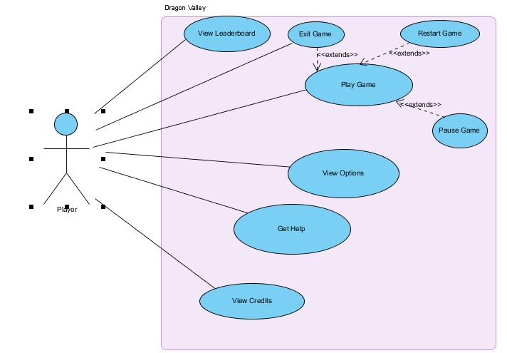

Figure 1.1: Use Case Model

**Use Case Name: View Leaderboard**  
  
**Primary Actor**: Player

**Stakeholders and Interests:**  
-Player wants to see top 5 scores with player names.  
-System shows top 5 players with their nicknames.  
  
**Pre-conditions:** Top 5 scorers’ points are kept record by the system  
**Post-condition: -**  
  
**Entry Condition:** Player selects “View Leaderboard” from Main Menu.  
**Exit Condition:** Player selects “Back” to turn back Main Menu.  
  
**Success Scenario Event Flow:**  
  
1.Top 5 scorers are displayed by the system.  
  
**Alternative Flows:**  
A. If player desires to return main menu at any time:  
 A.1. Player selects “Return to Main Menu” button to return main menu.  
 A.2. System displays Main Menu.

**Use Case Name: View Options**  
  
**Primary Actor**: Player  
  
**Stakeholders and Interests**:  
-Player desires to see the game options disabling or enabling sound.

-Player wants to choose the level difficulty.  
-System updates the recently changed options.  
  
**Pre-condition:** At first options are set as default. If Player arrange options different than default, changed settings will be saved and used by system.  
**Post-condition:** Options are updated.

**Entry Condition:** Player selects “Options” button from main menu.  
**Exit Condition:** Player selects “Back” to return main menu.  
  
**Success Scenario Event Flow:**  
1. Player presses “Options” button to make arrangements about game options.  
2. Options of the game are displayed to Player in “View Options” screen by System.  
3. Player adjusts settings according to her wish.  
4. System updates game settings successfully.  
  
**Alternative Flows:**  
A. If Player desires to use default settings at any time:

A.1. Player chooses “Default” button from “View Options” screen.  
A.2. System updates default game options.

B. If Player wants to return main menu at any time:

B.1. Player selects “Back” button from “Change Settings” screen.  
B.2. System updates Game Options..  
B.3. Player returns main menu.

**Use Case Name: View Credits**  
  
**Primary Actor**: Player

**Stakeholders and Interests:**  
-Player wants to see the creators of the game  
  
**Pre-conditions:** -  
**Post-condition: -**  
  
**Entry Condition:** Player selects “View Credits” from Main Menu.  
**Exit Condition:** Player selects “Back” to turn back Main Menu.  
  
**Success Scenario Event Flow:**  
  
1.System displays the developers.  
  
**Alternative Flows:**  
A. If player desires to return main menu at any time:  
 A.1. Player selects “Return to Main Menu” button to return main menu.  
 A.2. System displays Main Menu.

**Use Case Name: Get Help**  
  
**Primary Actor**: Player

**Stakeholders and Interests:**  
-Player wants to learn or revise the rules of the game.  
  
**Pre-conditions:** -  
**Post-condition: -**  
  
**Entry Condition:** Player selects “Help”Button from Main Menu.  
**Exit Condition:** Player selects “Back” to turn back Main Menu.  
  
**Success Scenario Event Flow:**  
  
1.System displays the instructions and rules.  
  
**Alternative Flows:**  
A. If player wants to return main menu at any time:  
 A.1. Player selects “Return to Main Menu” button to return main menu.  
 A.2. System displays Main Menu.

**Use Case Name:** **Play Game**  
  
**Primary Actor:** Player  
  
**Stakeholders and Interests:**  
-Player desires to complete all stages and reach to the top of the leaderboard.  
-The score of the Player recorded by the system.  
  
**Pre-condition:** In the first run, the difficulty level is default as in the Options Menu.  
**Post-condition:** According to the points of the player, the scoreboard is changed.  
  
**Entry Condition:** Player chooses “Play Game” button from Main Menu.  
**Exit Condition:** Player chooses “Return Main Menu” from Upper Menu.  
  
**Success Scenario Event Flow:**  
1.System starts the game.  
2.The first stage begins with the default difficulty level. (Blocks are set, Time begins)  
3.Player completes the stage by destroying blocks with fire, eating animals and earning sufficient points in the given time without hitting a block or an enemy.  
4.System opens the door in the stage.   
5.Player moves into to door and starts the next stage.

*Player does the steps 3 – 5 repeatedly until all stages are completed or Player hits a block or an enemy.*

6.System records the current points of the Player and if her score is greater than  
 any other competitor on the Leaderboard, system updates the leaderboard.

7.System turns back to Main Menu.

**Alternative Flows:**

1. If player requests to pause the game at any time during the game:  
   A.1. Player presses the Pause Menu Button from the Upper Menu.  
   A.2. The game is paused by the System.  
   A.3. The pause menu is shown by the System.

A.3.1. If Player chooses “Continue” Button from pause menu, System continues the game.  
A.3.2. If Player selects “Return to Main Menu” from pause menu, System directs Player Main Menu.

B. If dragon hits a block or an enemy.

B.1. The system stops the game.

B.2. The system shows the Game Over screen. (with Score, “Return Main Menu” and “Restart Stage” button)

B.2.1 If the player chooses “Return Main Menu” Button, the system displays the main menu.

B.2.2 If the player chooses “Restart Stage” Button, the system restarts the game.

C. If dragon eats a animal which is not dangerous.

C.1. The score screen is updated (score is increased) by the system with the point of the eaten animal type.

D. If the dragon eats a animal which is dangerous.

D.1 The score screen is updated (score is decreased) by the system with the point of the eaten animal type.

E. If the dragon collide with blocks the system ends the game and shows the game over screen.

F. If the given time approaches to finish time, the system notifies the player that the game is going to end.

G. If the player can not complete the game in the given time, the system ends the game and shows the game over screen.

H. If player hits an enemy, the system ends the game and shows the game over screen.

***2.7 User Interface***

**Main Menu:**

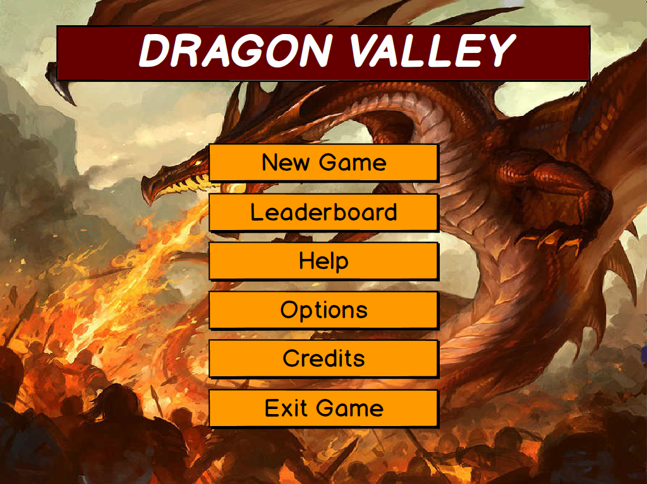

Figure 2.1: User Interface of Main Menu

When the application starts, user will encounter with this screen initially. On this interface, user can start a new game, check the leaderboard, check the help screen to learn game’s instructions and rules, click options to go to the options screen to turn off/on the game’s background music and to change the difficulty level, check credits to see the program’s developers’ information and exit the application.

**Leaderboard:**

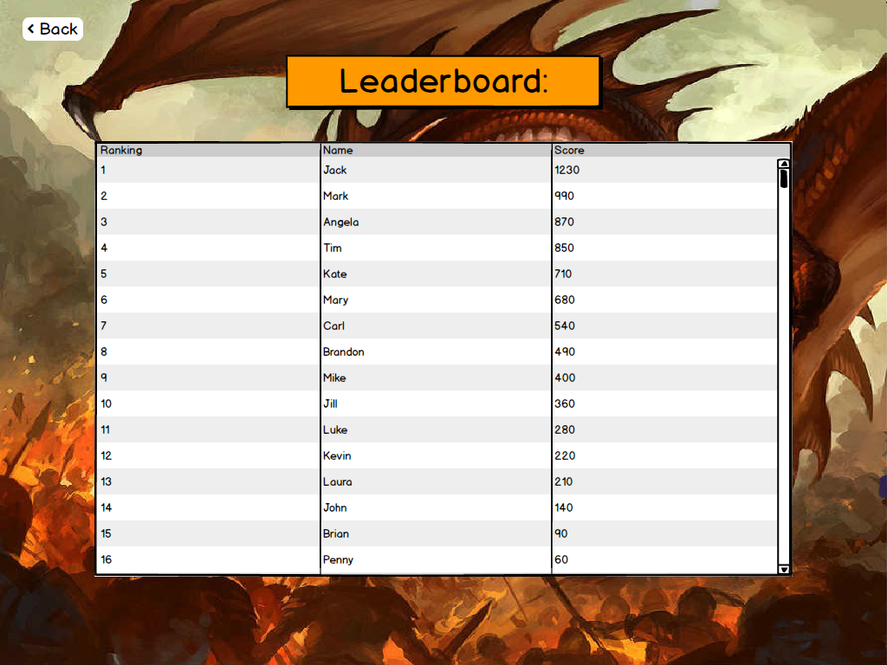

Figure 2.2: User Interface of Leaderboard

On this screen, user can check the leaderboard of the game to see his/her ranking. After playing the game user’s name and score goes to the database and it keeps this scores. The leaderboard is the place that user can see this scores on the database sorted by points bigger to smaller. By clicking back button, user can return to main menu again.

**Help:**

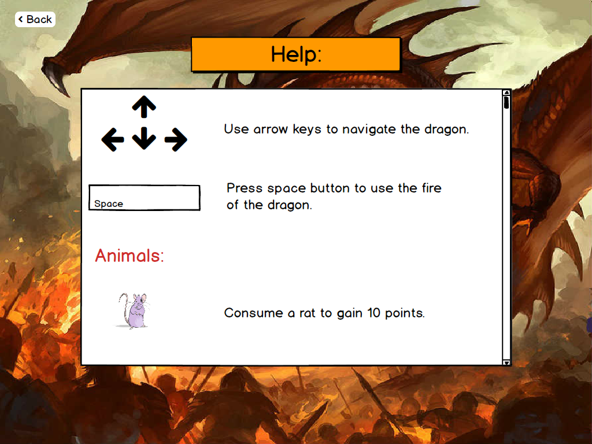

Figure 2.3: User Interface of the Help Section

On this screen, user can see the instructions and rules of the game like how can he/she play the game or which animal provides how many points etc. Like on the leaderboard screen, user can press back to go to the main menu.

**Options:**

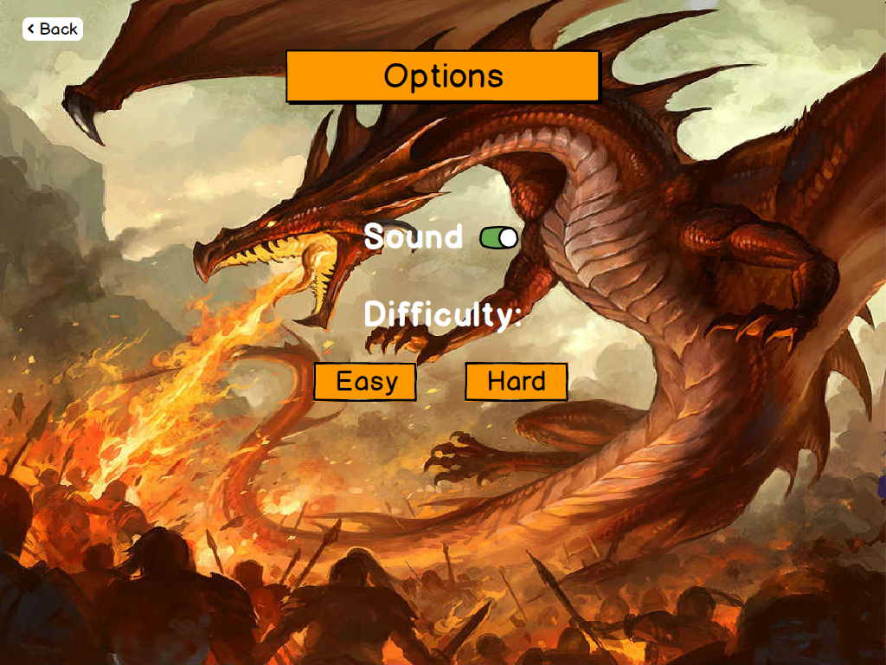

Figure 2.4: User Interface of Options

On the options screen, user can click the sound button to turn off/on the music of the game and choose a difficulty mode between easy and hard. If user selects hard mode, dragon become more fast and time for passing stages will decrease. By clicking back button, user can return to main menu.

**Credits:**

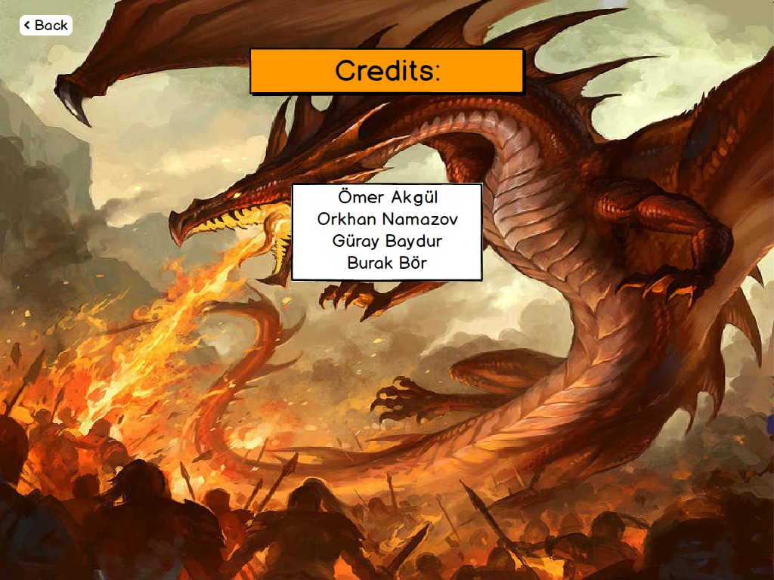

Figure 2.5: User Interface of the Credits Section

On this screen, user can see some information about application’s developers. Back button does the same action like on the other screens.

**After New Game:**

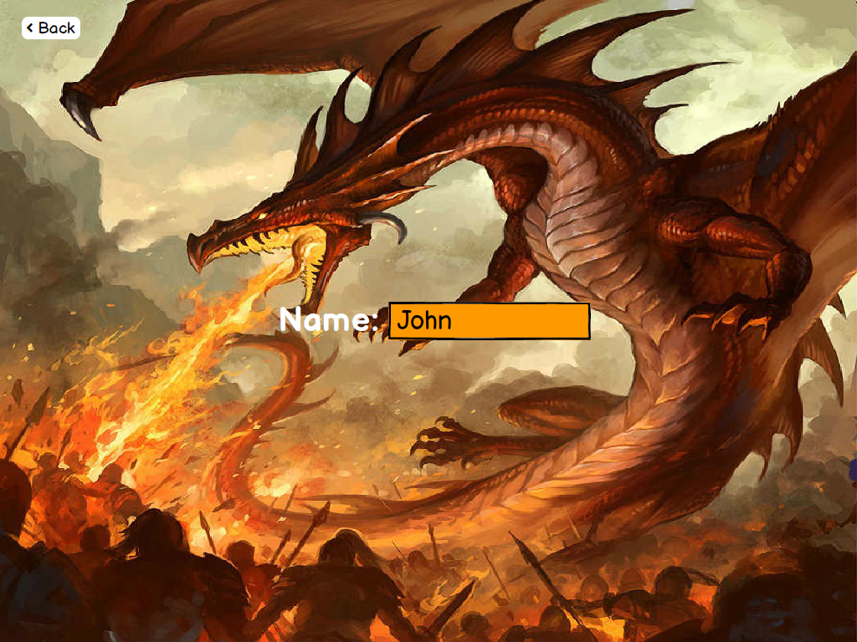

Figure 2.6: User Interface of the After New Game Screen

After clicking new game button on the main menu, application passes to this screen to learn user’s name. User have to enter his/her name and after writing the name user have to press enter button on the keyboard to start the game.

**Game Starts:**

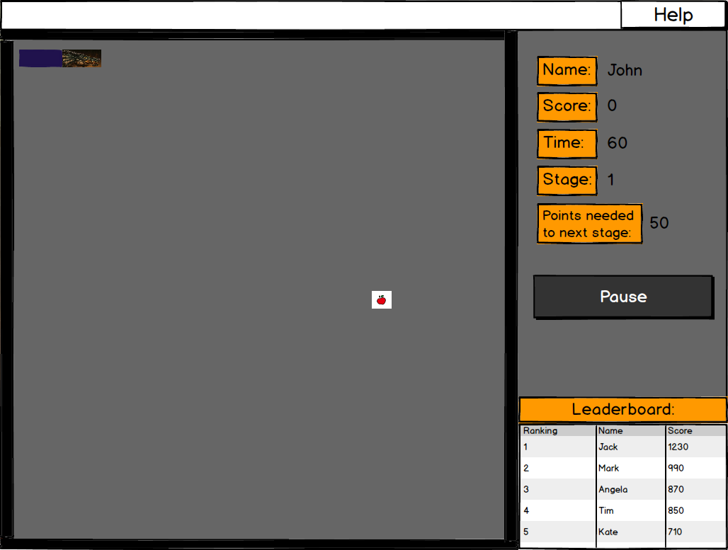

Figure 2.7: User Interface of just after game starts

After starting a new game, the game looks like this. On top left we can see our dragon and there is a animal to waiting to be consumed by our dragon. The left big square which our dragon and animal are inside, is the game board. Game continues on this place and if dragon touches the black borders of the board, game will be over. On the right section user can see the information about current game. User’s name, total score of the user, remaining time to pass the stage, which stage user is on, points needed to pass to the next stage and a mini-leaderboard. There is a pause button, if user clicks this button game freezes until pressing this button again. Clicking the help button on the top right of the screen opens the help screen which can be reached from the main menu.

**Blocks:**

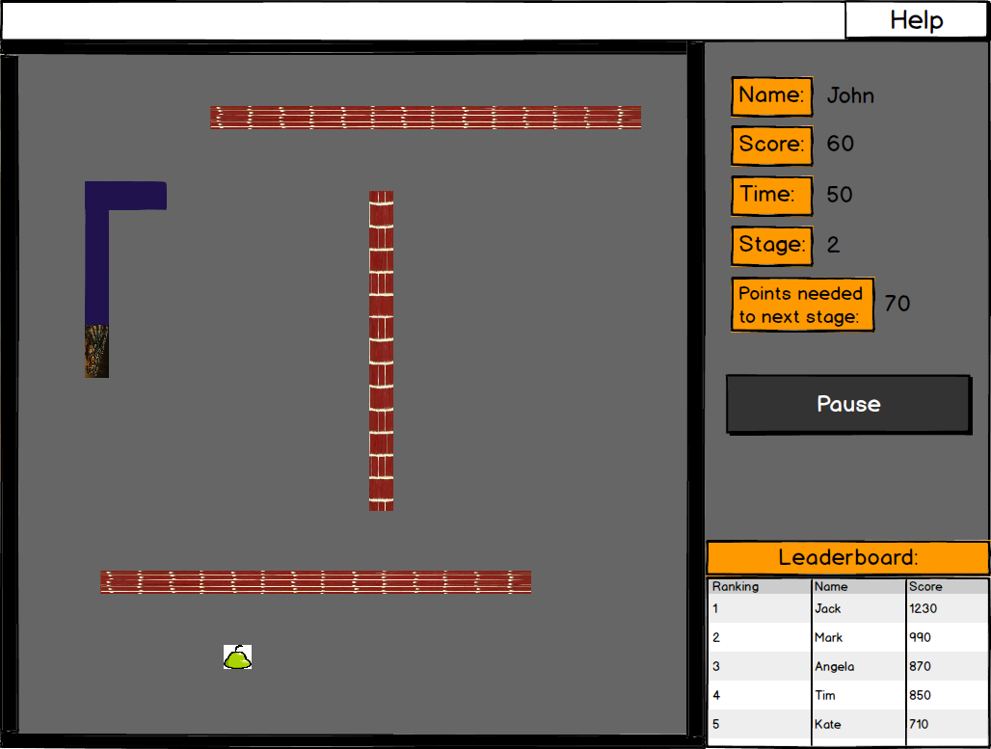

Figure 2.8: User Interface of blocks in the game

On this screen we can see that user passed to second stage and there are some blocks are appeared. Dragon must not touch these blocks if it wants to survive and pass to the next stages. Another type of animal can be seen in this visual.

**Further Levels, Fire and Enemies:**

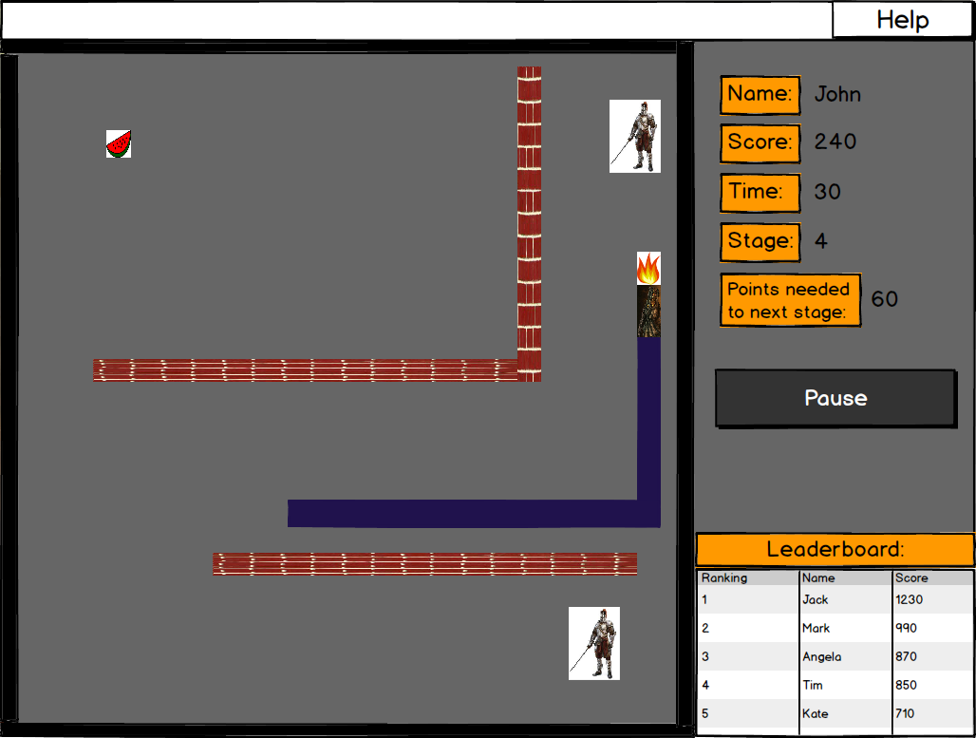

Figure 2.9: User Interface of enemies and fire

On this visual, it can be seen that player passed to a further level and game became more difficult than the first stages. Now dragon is longer, slides faster and there are more blocks appeared. As can be seen, there are enemies on the board. Our dragon can use its fire breath to destroy them and gain points for passing the next stages.

1. ***Analysis***
   1. ***Object Model***
      1. ***Domain Lexicon***

During the designing of a dragon valley game, more than one comprehensive domain had to be examined: gaming, game development, computer graphics game engines, user interface, content and logic. These examinations had been done both by doing research on existing systems and techniques, by researching on internet, or from our general knowledge. Most of result is known by gamers but all of them should be again written to this report.

**Game Engine:**

Game engine is core of our program. It never interacts with player but it will work behind of game infinitely. It checks all collusions, does calculations such as place of animals, blocks, enemies etc. Idea of this game engine is working autonomously at core of the game from game content, game logic, player.

**Board:** Board is a display of our game, it consists of grids. Everything thing is happening on this board visually. Game draws every object of game to board in order to show all events to user or player.

**Grid:** Grid is drawn on board in order to user can take all actions on it easily. We can see grid most of visual programs or games, in order to enable player to take action easily. Mostly, shape of grids are small squares.

**Draw:** Draw all objects that can be visualized to show user all objects on game. It provides user or player with graphical aspect of game.

**Real time:** It allows players to play in fair system. It means player can play for certain time interval and this interval is same for all players.

**X Width:** A graphical term, defines the X coordinate of a drawable object in the space.

**Y Length:** A graphical term, defines the Y coordinate of a drawable object in the space.

**Updates:** A game development term, update refers to applying all changes in the game logic to the game objects, usually dictated by the state of a game.

**Game Control:**

Game control unit controls all game. Game control interacts with user or player and core of the game which is game engine directly. Hence, we can see effects of game control unit on both game engine and game logic.

**Main menu:** It is first interactive interface of game. Most of the games star with this state. It allows user to choose from menu what user wants to do such as new game, help, options etc.

**Options:** Options submenu can be chosen from main menu so user should adjust settings before game starts. This submenu enables user to adjust settings of game, choose difficulty level, or sound effects. Therefore, user can choose game-play difficulty as easy or hard depend on skills on this game.

**Pressed buttons:** pressed buttons allows to control game when user plays game. In this game arrow keys will control our game such that direction of dragon will be chose by arrow keys. User will press one of the arrow keys where he/she wants to his dragon move on.

**Game Logic:**

Game logic actually sum of game control, game engine, game content because without any logic our game cannot be played or cannot be run by the user. Game logic consists of how game should be played, which functions should be done on this game, and how to interact with user and core of program at the same time independently. After interacting with user and core of game, it decides what should game do whether continue to play or stop playing. Correct calculations also done in this stage and by result of these calculations it does some events. Of course, everything is happening by the obeying rules of game.

**Dragon:** Dragon is main actor on this game. Dragon refers to an object on this game which can fire to enemy or eat animals.

**Fire:** Fire is an object that refers to dragon that can kill dragon’s enemies with fire. Dragon have limited fires to fire its enemies. Logic of fire like a bullet, it will be used for killing enemies of dragon.

**Enemy:** Enemies can be monster, people etc. that want to kill dragon. In this game enemies will try to kill dragon. However, dragon has to fight against to these enemies. Dragon should defense itself from these enemies by killing them.

**Game Stage:** Mainly most of games have many stages and in each of these stages user faces with lots of challenges. Every next stage always will be harder than current stage as well as dragon valley game. Dragon valley game also provides users with challenging stages, so that latest stages of this game also will be hard to play. When result of playing on current stage will be success, player will move on to the other stage, otherwise player will return back to first stage.

**Miss:** Miss means unsuccessful attack to its enemy on this game. Unsuccessful attack brings you to out of fires or end of your fires. When fire does not meet with its target, you can create problem for yourself due to the fact that enemy can kill you.

**Hit points:** All of the games hold on players score to show that how good each player on certain stage or on certain game. Also on this game which is dragon valley, we trying to calculate points or scores of players. Dragon eats some animals and gains some points from these animals but when it eats bomb, dragon’s points will be decreased.

* + 1. ***Class Diagram***

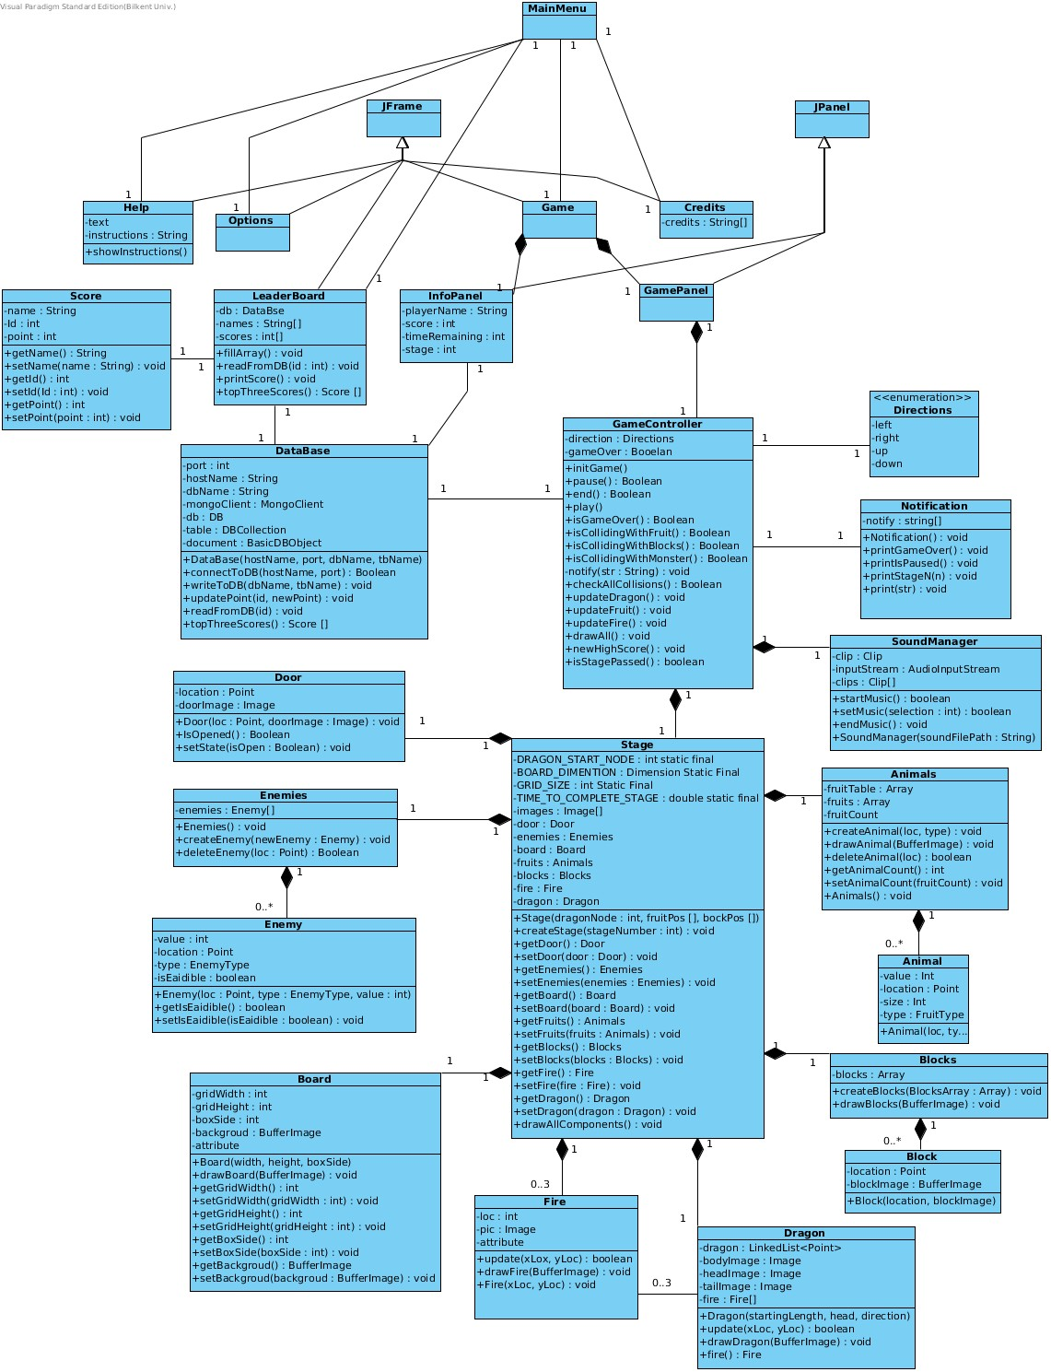

Figure 3.1: Class Diagram

**MainMenu:** The window that contains the options a player can choose. It is the first screen the player sees.

**Game:** The window that contains the GamePanel and the InfoPanel.

**InfoPanel:** This is panel in which the player can see the information about the game. It can bee seen in the user interface section of the report. It basically displays the top three scores and gives the left time, stage number, collected points etc.

**GamePanel:** shows the game components such as the Dragon, Bricks, Door, Enemies etc. The class is the visualization of the game.

**Options:** The window which the user can use to change the difficulty and play with the sound volume.

**Help:** The window in which the user can learn how to play the game.

**Credits:** This window simply shows the developer information.

**LeaderBoard:** This window uses the DataBase class and pulls the all the entries inside the DataBase in order to show the information to the player.

**DataBase:** This class is managed by the GameController and and serves the purpose of saving player informations and scores to a DataBase. It allows simple operations such as read and writes but does not allow complex queries.

**Score:** a class the LeaderBoard and DataBase uses in order to keep the information of each individual player as an object.

**GameController:** This class is the brain of the game. It is the main controller. This class interprets all inputs from the user and adjusts the components accordingly. The class also checks for any collisions with the dragon, if the time is up, and if the sufficient points are collected in order to pass the stage.

**Notification:** This is a basic class that the GameController uses in order to display information such as the pause, stage number in the beginning of the stage, broken record etc.

**SoundManager:** Takes care of the sound effects in the game is controlled by the GameController.

**Stage:** is a class to manage all the game components. All of the model objects have their reference here. GameController uses this class in order not to deal with all of the game componenets.

**Door, Enemies, Enemy, Board, Animals, Animal, Fire, Blocks, Block:** these are model classes they do not do any computation they exist to hold information of game components.

* 1. ***Dynamic Model***
     1. ***State Chart***

1. **Game State Chart:**

Game starts from default state, so it means that playable environment for player is starting from default state. Game will load first stage to default state and default state will create game object. Initially, player will only interact with animals. Therefore, player will eat some of animals which were chosen before. Game controller always will check it can move or not when one of the arrow keys is pressed. If one of the arrow key is pressed such as right, left, up, down keys, game controller will change direction of dragon towards that arrow key pressed. For example, if dragon move to right side and player pressed “UP” key, dragon will change direction of itself to upward. However, if there is blocks and it will not move. It will go default state from move and if there occurs collusion between dragon and block, state will change to end of game. Secondly, it will always check for time. If time is up, state also will be changed to end of game. On the other hand, in some time period, if dragon cannot eat some amount of animal, or this time period will be expired, it means game is end.

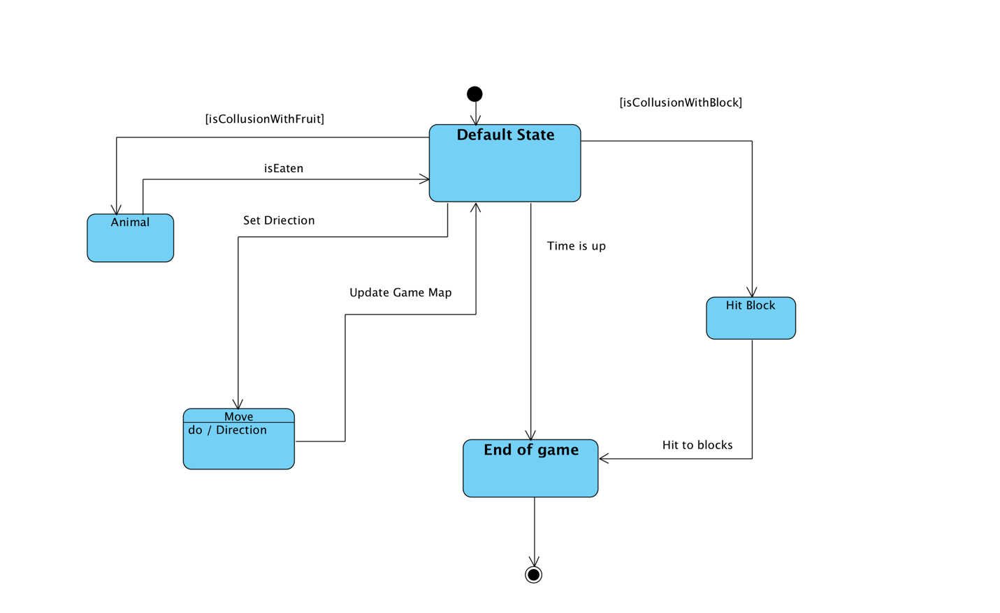

Figure 4.1: Game State Chart

### Character State Chart

Our character state is dragon that we will play this game as dragon. In this game, dragon will move until he will hit to blocks, or when he obtain appropriate score to pass stage. When he gets appropriate score, door will open and dragon can move from this stage to another stage. More general statement is “move” in this game. Dragon will eat animals, fire to enemies, try to don’t touch walls or blocks, so dragon will get points from eating animals and killing enemies. In this way, dragon will become larger and it can open door in order to go next stage. When dragon eat animal it will return our main state which is “move” state. When dragon fires to enemy and kills enemy it will return to again move state. “Move” state always checks door is opened or closed. It will continue check whether door opened or closed until door opens. In order to check door is opened, it will go to “door” state. When it will get that door is opened, stage or game ends.

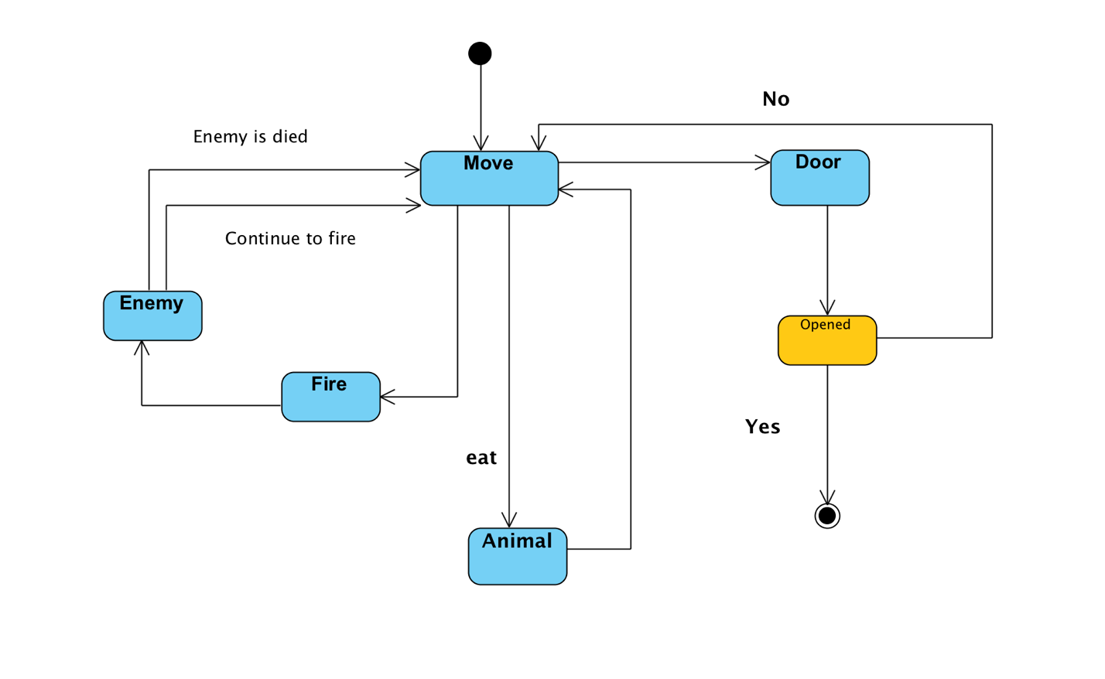

Figure 4.2: Character State Chart

* + 1. ***Sequence Diagrams***

Scenario name: Main menu operations.

Scenario: Burak starts the game and sees the main menu. He first takes a look at the leaderboard option then he continues by viewing help and credits.

The purpose is to show how the main menu works. Note that we show the new game option in the next sequence diagram.

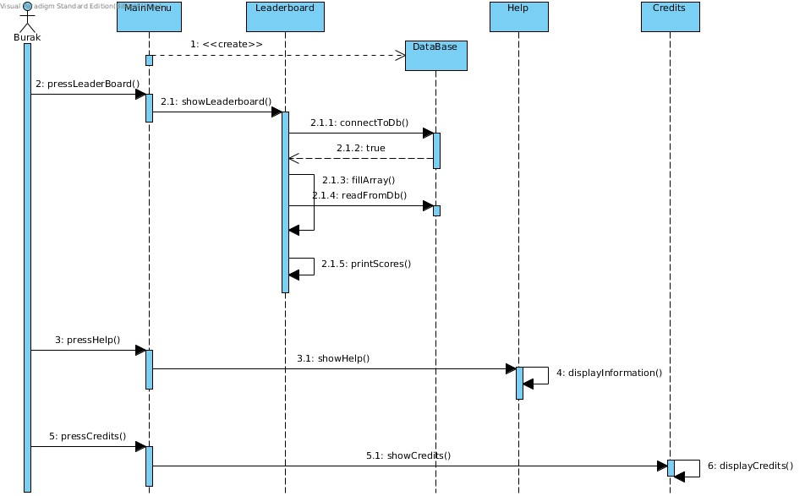

Figure 5.1: Main Menu Operation Sequence Diagram

Description:

After the game is started by the user the main menu pops up. The DataBase class is instantly instantiated without any user request. This is done to make the DataBase ready for the GameController class or the LeaderBoard class. When the user (Burak) clicks on the leaderboard option a new window pops up showing the previous high scored from other players as we can see in the user interface section. The selection makes the LeaderBoard connect to the DataBase and read from it until it fills an array with all the points. Next the values are displayed.

The user proceeds with selecting help which simply calls the help window and displays the information needed to play the game. Finally the user presses Credits which is very similar to the help screen but instead the displayed text is the names of the developers.

Scenario name: Basic Gameplay

Scenario: Omer starts the game and selects new game. He is greeted with the game and starts playing the game until he wins it or he fails it the game is over. This scenario shows how the game will execute when someone plays it.

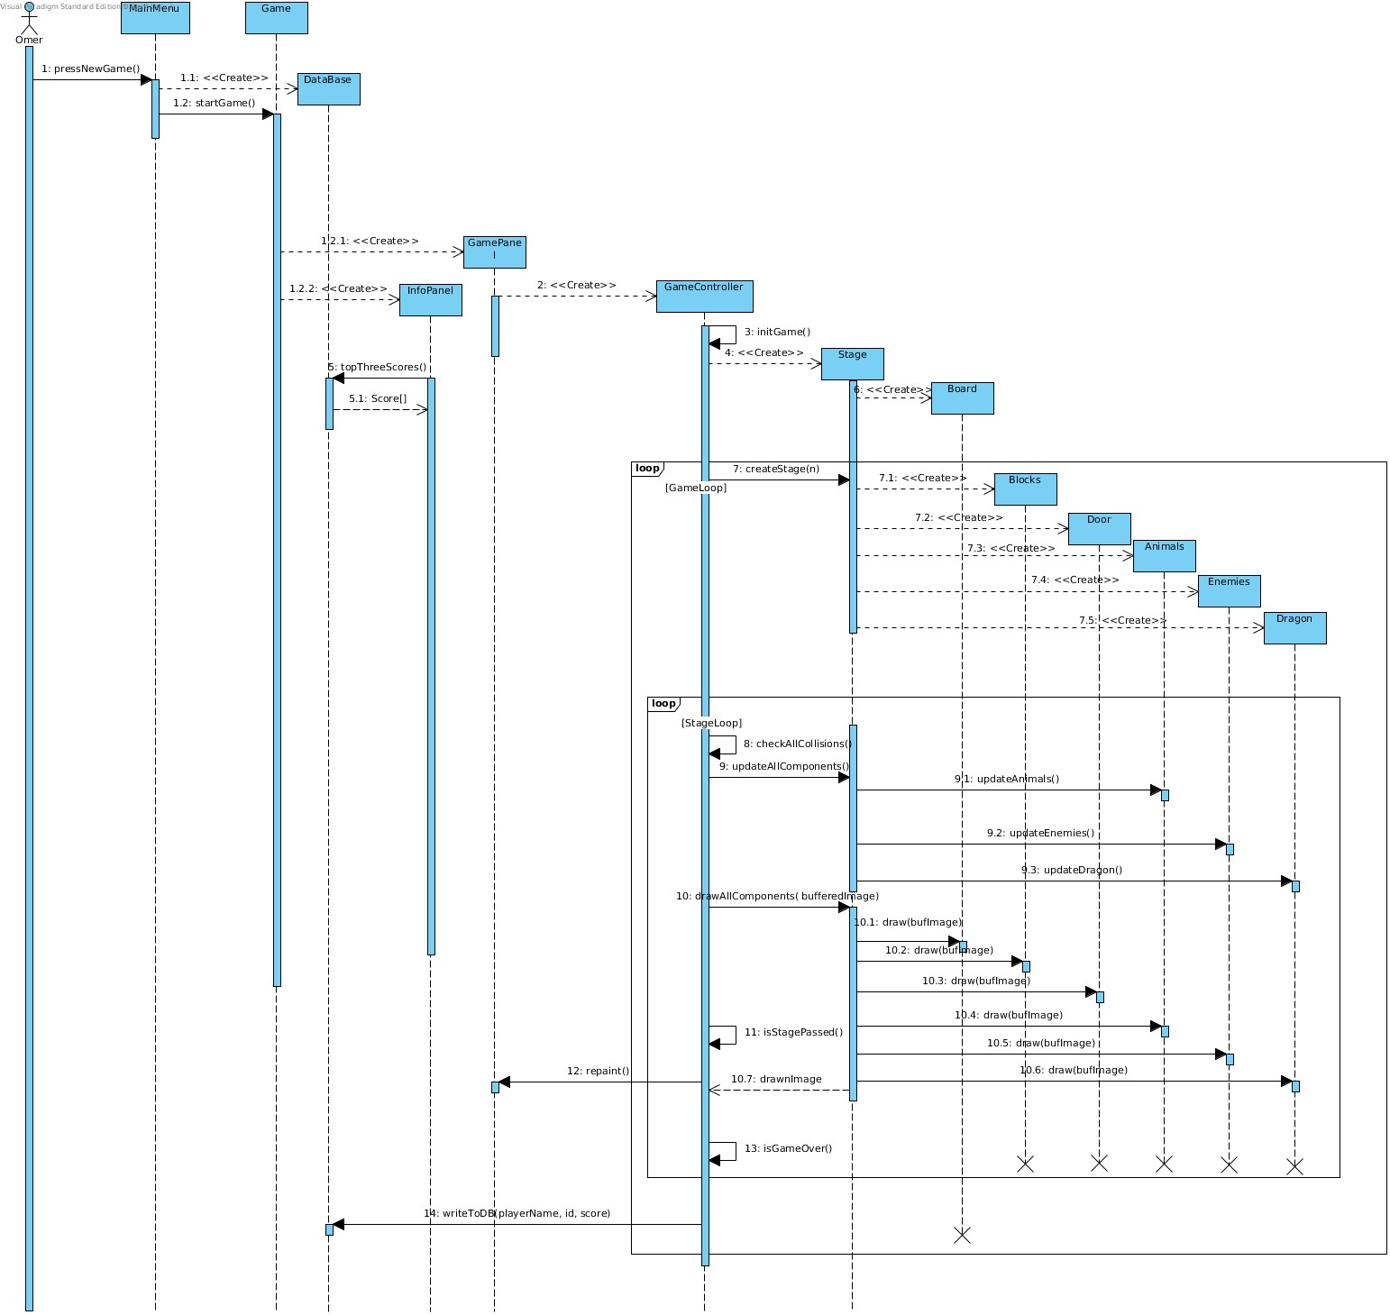

Figure 5.2: Basic Gameplay Sequence Diagram

Description:

Once the user (Omer) selects new game option the program shows the game window. This window instantiates two panels: InfoPanel and GamePanel which are used to show information about the game and the game screen respectively. The InfoPanel uses the DataBase object the MainMenu created and and gets the top three scores to display them. The GamePanel starts the game by instantiating a GameController object. The GameController class is the main controller in the game and all of the logic lies here.

The GameController creates a Stage. The Stage class then continues to create all the elements the game needs in order to be playable. The stage does this by the invocation of createStage(n). The Stage creates the stage requested by creating an instance of each Dragon, Door, Blocks, Enemies, Animals and Board. These are created inside the game loop because when we progress and proceed to the next stage these objects will have to be reinitialized. Board is outside the loop since it does not need to change between stages.

The GameController continues by checking for any collisions between elements. Since the stage has all the game elements it takes the references and compares for collisions. The stage loop ends if the stage is passed( either a win or a loose.) the game loop ends if the player loses or passes all stages successfully.

1. ***Conclusion***

In this Analysis report we outlined all the features in order to develop our Dragon Valley game. The two main parts of the report will be used to further develop and implement the game. The first part which comes after a brief introduction is the Requirements Analysis. The Requirements Analysis basically tells us how the game should be in terms of a user point of view. This part puts restrictions on the implementation and specifies the general outlines of the game.

In 2.2, 2.3, 2.4 we see how the game should respond to the user's actions. In essence this section shows the main functionalities of the game together with the restrictions it must follow.

In 2.5 we describe situations in which the user can end up in. This part tells how the program might execute. Some of these scenarios are described in much more detail in the UML sequence diagrams located in 3.2.2 .

In 2.6 the report presents use case diagrams. These diagrams show the the sates the game can be in and which states the user can end up in.

In 2.7 we can see the gui of our game. We have a couple of suggested gameplay footage as well as the functionality of how these scenes will respond to the user.

The second major part of the report is the Analysis part. This part will be used in order to code the game in java. The attributes and the methods of each class are shown and how these classes behave can be found in this part.

In 3.1.1 the report defines the domain lexicon. This section shows what the game consists of. It demostrates how the main parts of the game make the game work.

In 3.1.2 the report shows the main structure of the implementation. This uml class diagram can be directly used to generate the outline of the code (dummy classes that have all the attributes and methods but do not have implementation.). It is the blueprint of the code and perhaps the most important diagram for a non-developer to understand the structure of the program.

In 3.2.1 the report indicates a state chart. This state chart shows what states the can be in. This diagram also shows how transitions between states can occur.

In 3.2.2 we report the sequence diagrams. These sequence diagrams show how the execution of the game happens in terms of the classes of the program. The sequences start with the invocation of the user and continues by creating new objects and interacting with them.

In essence this report is our guideline to develop the Dragon Valley game. Note that this report is not final and must be revised as a part of the development process. This is due to the fact that we simply cannot foresee all of the possible cases of the game without first starting to implement the game.